**SUJET de Langues, littératures et cultures étrangères et régionales: ANGLAIS**

ÉVALUATION de première

Epreuve écrite

Durée: 2 heures

**Le sujet porte sur la thématique «Imaginaires».**

Prenez connaissance des documents A, B et C et traitez le sujet suivant en anglais:

**Write a short commentary (minimum 300 words) on documents A, B and C, using the following guidelines:**

**1. Analyse how *Animal Farm* can be read on different levels.**

**2. Explain why *Animal Farm* may be called a political satire.**

**3. Comment on the power of fiction / imagination and the role and responsibility of the writer.**

**DOCUMENT A**

I grew up with [George Orwell](https://www.theguardian.com/books/georgeorwell). I was born in 1939, and Animal Farm was published in 1945. Thus, I was able to read it at the age of nine. It was lying around the house, and I mistook it for a book about talking animals. I knew nothing about the kind of politics in the book - the child's version of politics then, just after the war, consisted of the simple notion that Hitler was bad but dead.

So I gobbled up the adventures of Napoleon and Snowball, the smart, greedy, upwardly mobile pigs, and Squealer the spin-doctor, and Boxer the noble but thick-witted horse, and the easily led, slogan-chanting sheep, without making any connection with historical events.

To say that I was horrified by this book is an understatement. The fate of the farm animals was so grim, the pigs so mean and mendacious and treacherous, the sheep so stupid. Children have a keen sense of injustice, and this was the thing that upset me the most: the pigs were so unjust. I cried my eyes out when Boxer the horse had an accident and was carted off to be made into dog food, instead of being given the quiet corner of the pasture he'd been promised.

The whole experience was deeply disturbing to me, but I am forever grateful to Orwell for alerting me early to the danger flags I've tried to watch out for since. In the world of Animal Farm, most speechifying and public palaver is bullshit and instigated lying, and though many characters are good-hearted and mean well, they can be frightened into closing their eyes to what's really going on.

**Margaret Atwood** *The Guardian June 16th 2003*

**DOCUMENT B**

|  |  |
| --- | --- |
| 5  10  15 | But if there were hardships to be borne, they were partly offset by the fact that life nowadays had a greater dignity than it had had before. There were more songs, more speeches, more processions. Napoleon had commanded that once a week there should be held something called a Spontaneous Demonstration, the object of which was to celebrate the struggles and triumphs of Animal Farm. At the appointed time the animals would leave their work and march round the precincts of the farm in military formation, with the pigs leading, then the horses, then the cows, then the sheep, and then the poultry. The dogs flanked the procession and at the head of all marched Napoleon's black cockerel. Boxer and Clover always carried between them a green banner marked with the hoof and the horn and the caption, "Long live Comrade Napoleon!" Afterwards there were recitations of poems composed in Napoleon's honour, and a speech by Squealer giving particulars of the latest increases in the production of foodstuffs, and on occasion a shot was fired from the gun. The sheep were the greatest devotees of the Spontaneous Demonstration, and if anyone complained (as a few animals sometimes did, when no pigs or dogs were near) that they wasted time and meant a lot of standing about in the cold, the sheep were sure to silence him with a tremendous bleating of "Four legs good, two legs bad!" But by and large the animals enjoyed these celebrations. They found it comforting to be reminded that, after all, they were truly their own masters and that the work they did was for their own benefit. So that, what with the songs, the processions, Squealer's lists of figures, the thunder of the gun, the crowing of the cockerel, and the fluttering of the flag, they were able to forget that their bellies were empty, at least part of the time.  George Orwell, *Animal Farm*, 1945 |

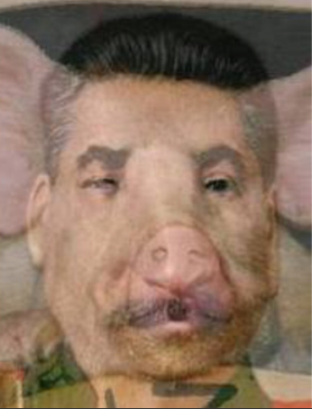

**DOCUMENT C**

<https://www.haikudeck.com/>